Gloucester City Council: Gender Pay Gap 2022
Executive Summary
Under the Equality Act 2010 (specific duties and public authorities) regulations 2017, gender pay gap reporting requires organisations with 250 or more employees to publish a gender pay gap report. This report states Gloucester City Councils mean and median Gender pay gap for ‘full pay relevant employees’ and is taken from a snapshot date of 31st March 2022. This report will also include findings from the 2021 Census where appropriate for comparison purposes. The findings of this report include:
- 58.5% of all our Employees are women
- The Mean Gender Pay Gap has decreased by 1.0%
- The Median Gender Pay Gap has decreased by 3.4%
Gloucester City Council have reduced both their mean and median pay gap. The median pay gap is now at 0% which means women and men are both paid a median wage of the same amount.
Introduction
The gender pay gap (GPG) shows the difference in the average earnings between all men and women within our organisation. We acknowledge that this report represents the legal sex of a person and may not be the gender they identify with.
Gender Pay Gap (GPG) relates to Gloucester City Council ‘full pay relevant staff’ in post as at 31st March of the relevant year. Full pay relevant employee is defined by the ‘Government Gender Pay Gap 2022 guidance’ document (which includes casual/zero hours staff who have worked in the period, but excludes people who have not received their full pay for the month due to leave e.g. unpaid leave, reduced pay sickness absence, reduced pay maternity pay, or staff who have started/left during the month).
The gender pay gap is defined as the difference in mean and median pay between men and women. The gender pay gap is calculated as the difference between the female mean (average) and median (mid-point) hourly earnings (excluding overtime) as a proportion of the male mean and median gross hourly earnings (excluding overtime).
The pay rates used in the GPG calculations are based on an hourly pay rate, which for the purpose of the calculation, includes basic pay also takes into account various salary sacrifice and/or additional payments (excluding overtime) received by staff (as required by the statutory GPG reporting criteria).
The mean averages place the same value on every number they use, giving a good overall indication of the gender pay gap, but very large or small pay rates or bonuses can ‘dominate’ and distort the answer.
The median averages indicate what the ‘typical’ situation is i.e. in the middle of an organisation and are not distorted by very large or small pay rates or bonuses. However, this means that not all gender pay gap issues will be picked up.
GPG: Number of full relevant employees
In 2022 Gloucester City Council had 253 GPG reporting relevant staff. This is higher than in previous years, 236 in 2021, 222 in 2018 but lower than 254 in 2020, 255 in 2019. In 2022 there remains a higher proportion of female staff (58.5%) which is consistent with previous years. The workforce gender profile has maintained relatively consistency throughout the reporting periods from 2017 – 2022 (ranging from 55.3% to 58.5% female).
Of the 253 GPG reporting relevant staff, 236 were permanent or fixed term (i.e. staff cohort usually counted within City corporate workforce reporting) and 17 zero hour / casual staff / temporary staff.

GPG Starters & Leavers
In GPG 2022 there is 17 more GPG full relevant staff than in 2021. A total of 46 staff who were in GPG 2021 were no longer in the staff cohort for 2022 (either due to leaving the council, or being classed as non-full pay relevant as per the national Gender Pay Gap guidance) and 63 new staff entered the staff cohort for the purpose of the GPG 2022 calculation.
Of the 46 GPG leavers, 67.4% were female compared to 65.1% of the 63 GPG starters. The highest proportion of starters (38.1%) are within the lower quartile, where the gender split for starters was 66.7% female and 33.3% male, whilst the highest proportion of leavers have been seen in the Lower Middle (28.3%) where the gender split for leavers was 84.6% female and 15.4% male. The lowest proportion of starters (19.0%) have been seen in the Upper quartile, where the gender split for starters was 50.0% female/male, whilst the lowest proportion of leavers have been seen in the Upper Middle (21.7%) where the gender split for leavers was 60.0% female and 40.0% male.
These differences impact the overall gender pay gap figure, due to the small number of staff in City Council relatively small changes can significantly impact the figures, resulting in the decrease of Mean GPG and Median GPG for 2022 reporting.

GPG: Number of staff by gender
Graph 1 and 2, GPG starters and leavers

GPG: Mean & Median
The Mean gender pay gap in 2022 is lower compared to 2021, 2020 and 2018 and higher compared to 2019, Median gender pay in 2022 is 0.0% and is the lowest when compared with previous years (2018-2021).
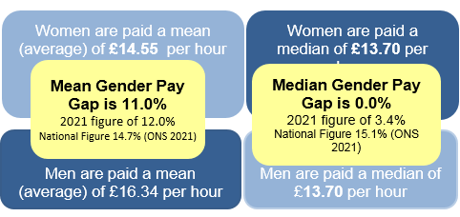

 | 2018 | 2019 | 2020 | 2021 | 2022
Mean GPG | 15.40% | 5.40% | 11.80% | 12.00% | 10.96%
Median GPG | 12.00% | 1.50% | 5.10% | 3.40% | 0.00%
Mean Pay Female | £12.45 | £13.26 | £13.25 | £14.57 | £14.55
Mean Pay Male | £14.71 | £14.02 | £15.02 | £16.56 | £16.34
Median Pay Female | £11.38 | £11.97 | £12.07 | £13.20 | £13.70
Median Pay Male | £12.93 | £12.15 | £12.72 | £13.66 | £13.70
Table 1. GPG (mean and median) and mean and median pay shown by gender (2018-2022)
The pay rates used in the GPG calculations are based on an hourly pay rate, which for the purpose of the calculation, includes basic pay; also takes into account various salary sacrifice and/or additional payments (excluding overtime) received by staff (as required by the statutory GPG reporting criteria). In addition to basic pay, 6 staff received a market rate supplement payment, 36 staff received first aid allowance, 1 staff received honorarium payment and 17 staff had deductions to pay due to salary sacrifice schemes.
As at 31 March 2022, Gloucester City Council had a mean (average) gender pay gap of 10.96% and a median (mid-point) pay gap of 0.00%, a decrease from 12.00% mean and 3.40 % median last year. Table 1 shows both the mean and median pay for both female and male staff compared to last year. The mean male pay has decreased by £0.22 and for female staff it has decreased by £0.02 compared to 2021. However, the mean pay for female staff is £1.79 lower than male staff, compared to £1.99 last year (2021) resulting in a decrease in the mean GPG. The median male pay has increased by £0.04 whilst the median female pay has increased by £0.50 compared to last year, resulting in a zero median GPG. A lower mean and a lower median indicate that there is a lower GPG when looking at the ‘typical’ (i.e., middle of an organisation), and overall, within the organisation there is now a zero median GPG. However, when looking at the quartiles in more detail, there remains a higher GPG particularly within the upper quartile (this detail can be seen in Table 7 and 8). It should also be noted that due to the low number of staff at Gloucester City Council small differences in staffing can significantly impact GPG.
The council has significantly lower figures than the national picture for the public sector. The office of National Statistics Annual Survey of hours and earnings in 2021, reported the overall gender pay gap to be 14.7% and the median gender pay gap as 15.1% mean; with the public sector GPG as 17.3% median, and 14.6% mean. The median is also lower than the Local Authority average of 5.4% mean and 3.6% median (Gender Pay Gap Service 2021-22).
GPG: Mean & Median – Full Time and Part Time
The GPG is based on hourly pay rates which ensures full time and part time employees are considered on an equal basis. Reporting on GPG for full time and part time employees is not a statutory requirement at this time, however for information / interest information on this aspect is provided below. The ONS reports on GPG in this way as part of the Gender Pay Gap and Annual Survey of Hours and Earnings (ASHE) and therefore benchmarking data is available.
A higher proportion (35.14%) of female staff work part time compared to (17.14% of male staff). For the purpose of this report part time is defined as less than 30 hours (for consistency with ONS reporting).
Table 2. Proportion of Female and Male employees who work full time / part time
Gender | Female |  | Male
 | Number | % | Number | %
Full time | 96 | 64.86% | 87 | 82.86%
Part time | 52 | 35.14% | 18 | 17.14%
Total | 148 | 100.00% | 105 | 100.00%
The mean and median hourly pay for part time employees for both men and women is lower than full time employees. The mean and median GPG is lower when Gloucester City Council’s full time and part time staff are considered separately, in fact there is a negative mean and median GPG for part time staff (female employees paid more than male employees). However, as more female employees work part-time the lower hourly pay rates in these roles will continue to contribute to the overall gender pay within the council. For full time staff there remains a GPG (females paid less than men), This is shown within Table 3 and 4 below.
Table 3. Mean Hourly Rate and Gender Pay Gap (FT / PT) | Table 4. Median Hourly Rate and Gender Pay Gap (FT / PT)
Gender Mean Hourly Rate Mean GPG (FT/PF)  Female Male  Full time £15.52 £17.39 10.7%  Part time £12.75 £11.27 -13.2%  Total £14.57 £16.56 11.0% | Gender Median Hourly Rate Median GPG (FT/PT)  Female Male  Full time £15.49 £15.59 0.6%  Part time £11.86 £11.17 -6.1%  Total £13.70 £13.70 0.0%
Gloucester City Councils Full Time GPG is lower than the national ONS GPG 2021 mean of 11.8% and median of 7.7%. Both the council’s Part Time mean and Part Time median are also lower than the national figures of 3.7% and negative 3.00% respectively. Gloucester City Councils full time GPG is also lower than the Public Sector figures (ONS GPG 2021) of 11.9% mean and 11.8% median and the part time GPG 19.5% mean and 18.6% median. Please see the below section on Benchmarking data for further detail.
Pay Quartiles:
Table 5 below shows the pay range in each quartile in the 2018, 2019, 2020, 2021 and 2022 GPG calculation. The pay ranges per quartile are slightly different due to national pay increases and staffing differences between the years.
Table 5. Pay range in each quartile 2018-2022
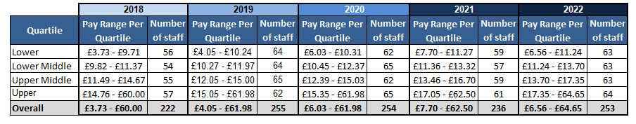
The split for each of the 4 quartiles is broadly in line with our workforce demographics of 58.5% women and 41.5% men. There are a slightly higher proportion of women in the first 3 quartiles and same number of women and men in 4th quartile (the upper pay quartile) (illustrated within Table 6and Graph 1). This is a key factor for GPG as (proportionately) more women at the lower grades and fewer women at higher grades affects the mean and median pay for the female workforce. For there to be no GPG you would expect to see the workforce demographics reflected in each quartile.
Table 6 & Graph1. Proportion of male and female staff in each pay quartile (March 2022)
Quartile | Gender |  |  |  | Total
 | Female |  | Male
 | Number | Female% | Number | Male %
Lower | 39 | 61.9% | 24 | 38.1% | 63
Lower Middle | 37 | 58.7% | 26 | 41.3% | 63
Upper Middle | 40 | 63.5% | 23 | 36.5% | 63
Upper | 32 | 50.0% | 32 | 50.0% | 64
Total | 148 | 58.5% | 105 | 41.5% | 253

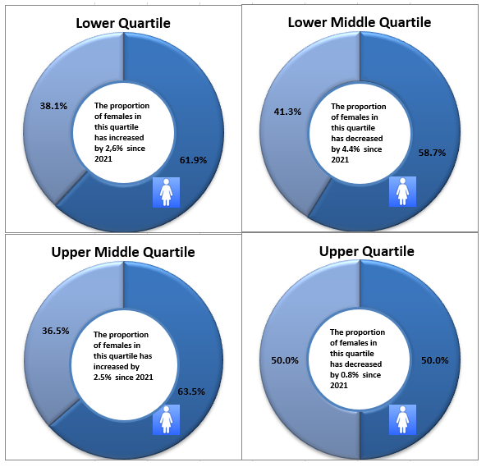
Examination of the pay quartiles in more detail and carrying out the GPG calculations on these subsets of data finds that in lower middle and upper quartiles there is a gender pay gap, meaning female staff are paid a lower hourly pay rate than male staff. This is particularly prominent within the upper quartile, where there is a wider variance in male and female mean and median hourly pay rates, this subsequently impacts the overall mean GPG. However, within the lower and upper middle quartiles (mean) and lower (median) there is a negative (minus) gender pay gap, meaning female staff are paid a higher hourly pay rate than male staff.

Table 7. Mean female and male hourly rate and GPG by quartile (2021) | Table 8. Median female and male hourly rate and GPG by quartile (2021)
Quartile Mean Hourly Rate Mean GPG  Female Male  Lower £10.23 £9.88 -3.5%  Lower Middle £12.32 £12.47 1.2%  Upper Middle £15.42 £15.10 -2.2%  Upper £21.30 £25.21 15.5% | Quartile Median Hourly Rate Median GPG  Female Male  Lower £10.38 £10.18 -2.0%  Lower Middle £12.16 £12.29 1.0%  Upper Middle £15.59 £15.59 0.0%  Upper £19.97 £22.04 9.4%
Table 10 below shows the proportion of male and female staff in each of the pay quartiles in the 2018, 2019, 2020, 2021 and 2022 GPG. In this years (2022) GPG there was a higher proportion of females in the lower pay quartile and upper middle quartile compared to the last year (2021); the upper middle pay quartile is the quartile with the highest proportion of females (a higher proportion than last year); the proportion of females within the lower middle and upper quartiles has decrease.
Table 10. Proportion of male and female staff in each quartile 2018-2022
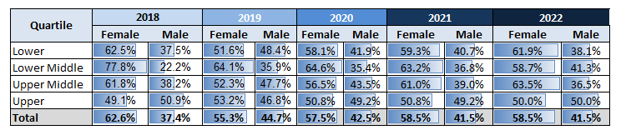

National Context / Benchmarking:
- ONS: Gender Pay Gap in the UK :
In the UK the official source of statistics on the gender pay gap is the Office for National Statistics (the ONS). The Office for National Statistics calculates the gender pay gap from data drawn from the Annual Survey of Hours and Earnings (ASHE), and in April every year it publishes a Bulletin which includes its analyses of the gender pay gap. ASHE is based on a 1% sample of jobs taken from HM Revenue and Customs Pay As You Earn (PAYE) records. In 2017 the government required employer employing more than 250 staff to report their gender pay gap information; that initiative is separate from this ONS publication, ONS do not provide analysis on these submissions. (Source ONS: Gender Pay Gap in the UK: – Compiled from the Annual Survey of Hours and Earnings).
Table 11 - Key Figures from the ONS GPG 2017-2021:
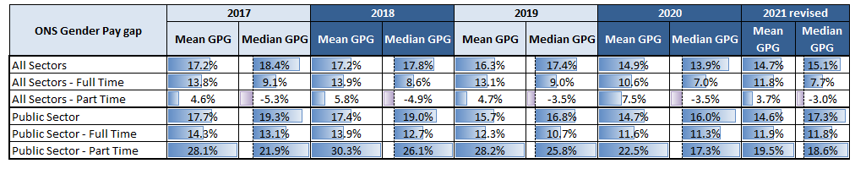

https://www.gov.uk/guidance/making-your-gender-pay-gap-calculations
ONS: Gender Pay Gap in the Uk – This statistical bulletin is compiled from the ONS Annual Survey of Hours and Earnings)

