

Consultation for Public Space Protection Order (PSPO)
Kings Walk Car Park, Gloucester, GL1 1EA
and
Eastgate Street Car Park, Gloucester GL1 1XN

Gloucester City Council, under Section 59 of the Anti-Social Behaviour, Crime and Policing Act 2014 is satisfied on reasonable grounds that –
- activities carried out in the above location(s) have had a detrimental effect on the quality of life of those in the locality, or that it is likely that activities will be carried out in the locations will have such an effect and,
- the effect or likely effect of the activities-
- is or is likely to be persistent or continuing in nature
- is or is likely to be unreasonable and justifies the restrictions imposed by the notice.
Background
Gloucester is a vibrant multicultural city that combines historic architecture with a unique blend of visitor attractions. Our city centre boasts a mixture of major stores and independent and regional retailers, many of which are unique to Gloucester and make the city an ideal place to visit. It is important for those living, visiting and working within Gloucester to feel safe, healthy and supported with services we offer as a Council and in collaboration with our key partners.
Both Kings Walk and Eastgate Street Car Parks are located in the heart of the City Centre and are used daily by a considerable amount of individuals to park their vehicles and use the amenities within the Centre. Gloucester City Council retains ownership of both car parks listed within this consultation and is keen to encourage the safe use of these facilities to increase footfall within the city centre.
For over 10 years, Gloucester City Council has received frequent reports of consistent anti-social and criminal behaviour within both KINGS WALK Car Park and EASTGATE STREET Car Park. Activities and behaviours reported to the Council and key partners include:
- drug use (including the discarding of drug paraphernalia),
- human waste,
- sleeping in the stairwells and obstructing exits
- damaging or the defacing of property.

Reports and observations undertaken by the Council have noticeably increased within the last six months, deeming the location as a ‘hotspot’ for criminality and anti-social behaviour.
From evidence gathered, groups of individuals who are behaving anti-socially are not using the car park for its intended purpose. Members of the public who are accessing both car parks for the purpose of parking their vehicles are then often impacted negatively by these behaviours and less likely to return to the location.
The land outlined in red in Schedule 1 are referred to as (“the Designated Area”).

History and Challenges
The Council has no current power to stop persons from socialising or congregating within the Designated Area unless there is evidence that an identified individual(s) has caused alarm, harassment or distress. Identifying and evidencing individuals responsible for anti-social behaviour in an area of high footfall and use can be challenging for varying reasons.
- Between April 25 – January 2026, Gloucester City Council has invested significantly in external security resources to patrol the Designated Area(s) due to the reports of anti-social behaviour. The Council has also undertaken several repairs to damages and invests in a robust cleansing schedule.
- In September 2025, the Council utilised its powers under Section 61 of the Criminal Justice and Public Order Act 1994 which enabled the removal of trespassers on land who are believed to have caused damage, disruption or distress. With support from the Police, persons were asked to leave the vicinity and not to return within a 12 month period. The Council were forced to close one of the Designated Area(s) for a duration of four days due to the extent of damage and cleaning required. Issues of a similar nature returned to the location within a short period of time.
- In February 2026, Gloucester City Council applied to Gloucester County Court for a Civil Injunction on another location due to similar challenges, under the Anti-Social Behaviour, Crime and Policing Act 2014. The application sought an order with a condition to request individuals who were believed to not be using the car park for its intended purpose to leave. Following further legal advice, this was not seen as the most appropriate solution that could be mirrored in other areas.
The Council has received continuous reports of groups or individuals using the Designated Area for the purpose of rough sleeping. Gloucester City Council is focused on ending rough sleeping and will engage with and support any individual found within the vicinity of the car parks alongside key partners and agencies. The Council is committed to a graduated ‘Engage, Support, Enforce’ approach where necessary and proportionate when dealing with persons who are believed to be linked to crime or anti-social behaviour within the City.
The Council seeks to apply for a Public Space Protection Order (PSPO) to enable authorised persons the power to direct persons from these locations if they have reason to believe that they are not using the Designated Area for its intended purpose and that they are causing, or likely to cause a detrimental effect on the local community.

Data and evidence
Gloucestershire Constabulary Crime Figures from 01/02/2024- 01/02/2026
Crime Type | Number of Incidents Reported
Theft from Motor Vehicle | 1
Theft of Motor Vehicle | 1
Criminal Damage to £5000 | 7
Theft | 1
Assault – Actual Bodily Harm | 2
Intentionally / Recklessly causing a public Nuisance | 3
Harassment | 2
Possession of Cannabis- Class B | 5
Supply / offer Cannabis – Class B | 1
Sexual Offences | 1
Other | 1
Total | 32
Incidents reported to the police between May 2025 and October 2025.
- Incident 128 20/10/25 – Rough sleepers refusing to move and being abusive
- Incident 440 14/6/25 – Taking drugs
- Incident 468 12/7/25 – Homeless fighting amongst themselves
- Incident 133 30/8/25 – 10 homeless taking drugs and being loud a abusive
- Incident 164 30/8/25 – Shouting and swearing and smoking
- Incident 174 1/9/25 – Homeless being attacked and having things stolen
- Incident 71 2/9/25 – Eviction of Individuals from the Vicinity

Gloucester City Council Figures 2025-2026 = 29
Annual figures for cleaning and maintenance for Kings Walk and Eastgate Street Car Park due to the anti-social behaviour.
  - Since April 2025 – November 2025 £11,290.99 has been spend on cleaning and maintenance. The Council have had to call out a specialist cleaning company due to the state which of course costs more money.
  - The Council also lost revenue to 4 days as the car park had to be closed for a deep clean back in September 2025.
  - Between April 2024 and March 2025 it cost the council £35,801.25 on cleaning an maintaining the 3 multistorey car parks in Gloucester. The 3 car parks include Kings Walk, Eastgate Street and Longsmith Street.

  - Since April 2025 – January 2026 it has cost Gloucester City Council £1,502.26 to hire in security to patrol the multi-storey car parks due to the reports of anti-social behaviour.

  - Gloucester City Council has had to request a Contractor to maintain Kings Walk and Eastgate Street Car Park. This table is how many requests over each financial year.

2023-2024 | 25
2024- 2025 | 38
2025 – 2026 (Feb) | 17

Evidence of this Anti-Social Behaviour in this designated area can be found in Appendix 1
Summary
Gloucester City Council seeks to apply the following conditions to both EASTGATE STREET CAR PARK and KINGS WALK CAR PARK
No person shall occupy, loiter in, congregate with other people or use the designated area outlined on the map for any other purpose other than to park a motor vehicle, motorbike or moped.
Where a constable or an authorised person reasonably believes that a person:
        - is or has been occupying, loitering, congregating with other people or using the Designated Area for any other purpose than parking, or
        - intends to breach the above condition within the order,
the constable or authorised persons may require that person to vacate the Designated Area immediately.
This Order will apply to all land within the Designated Area of Kings Walk Car Park, Gloucester, GL1 1EA and Eastgate Street Car Park, Gloucester GL1 1XN, including stairwells, lifts and corridors as in Schedule 1.
Consultation
The Council will undertake a consultation from the 07th April 2026 to allow for the opportunity for members of the public and interested parties to submit responses. Submissions for responses will close on 26th May 2026.
If you wish to submit a response to the proposed Public Spaces Protection Order, you can do so via the following methods:
- In writing to ‘PSPO Consultations, Gloucester City Council Gloucester
City Council
Eastgate Management Suite
Eastgate Street
Gloucester
GL1 1PA
- or via email to ASB@Gloucester.gov.uk
- Via our online form here.
More information relating to Public Spaces Protection Orders and live orders across the Gloucester can be found here: Public Spaces Protection Orders | Gloucester City Council

SCHEDULE 1 - Kings Walk and Eastgate Street Car Park Map
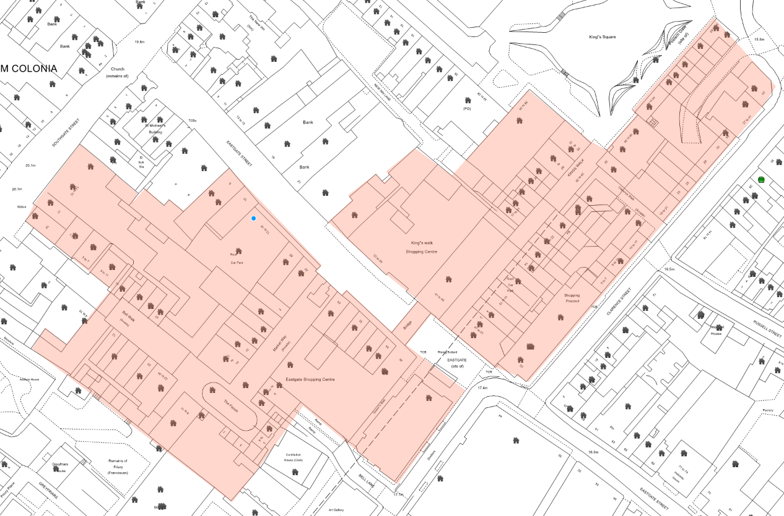
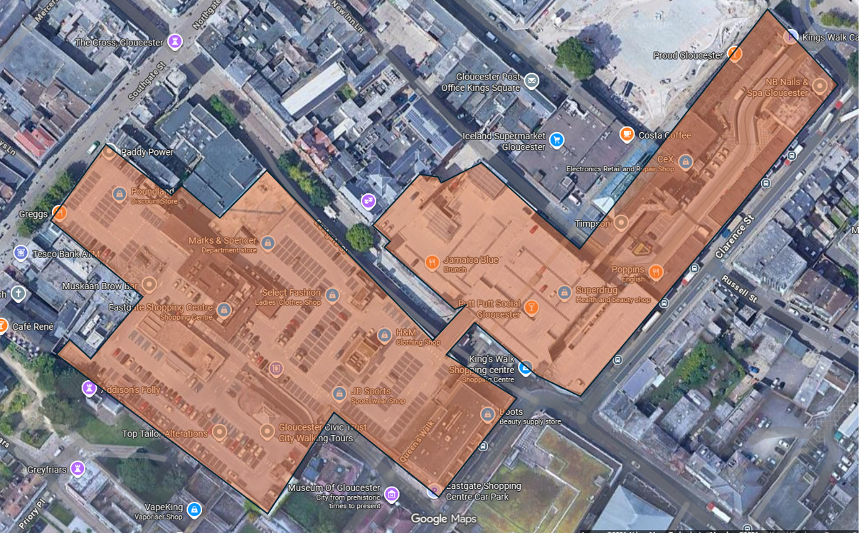

APPENDIX 1
Reports and further information
GCC Officer – 9th February 2026. Puddles of Human Urine on each floor of Kings Walk Car Park.

GCC Officer – 15th January 2026. Human Urine was dripping down the stairwell of Kings Walk Car Park. The smell was that bad it caused the officer to gag.
GCC Officer - 19th November 2025. Both car parks were being used by individuals sleeping in and using the stairwells for certain activities. A large amount of drug paraphernalia including used needles and burnt tin foil used in the consumption of illegal drugs were found and removed by cleansing teams.
Member of public – 19th September 2025. "I am contacting you to express my horror at the disgusting goings on in Kingswalk car park! "Today I witnessed one of the inhabitants of the carpark using the space between cars as a public lavatory, setting off a car alarm in the process."I am utterly ashamed of the city, considering it is The County Town."There are many homeless people using the car park as their very own lodgings."The mess they are making is disgusting. They have taken up residence in several spaces and installed themselves and put up barriers, flags etc."I personally feel quite unsafe when I have to get out of my car to walk to the lift, as would any other single person! "The numbers are growing all the time and I really think it's time something was done - people are going to stop using the car park and will eventually stop coming into the City Centre."This is a terrible situation to find ourselves in and on one seems tove taking the slightest bit of notice of residents fears and feelings."
An image was provided by complainant:
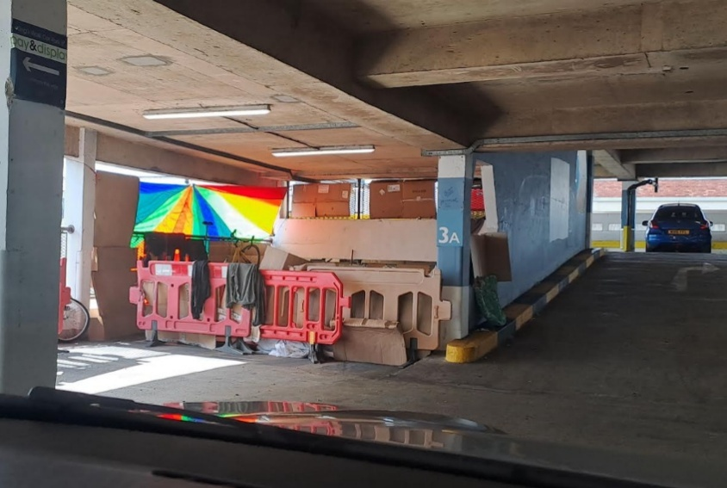
Business Owner – 10th September 2025. As a follow up, one thing I want to flag is the urgent need for improvements to the Kings Walk car park. It appears the situation is becoming worse, with increasing counts of homelessness and open drug use in the car park. This is also leading to threatening and intimidating behaviour towards our staff members, to the point where they no longer feel safe coming in to work.
This is obviously unacceptable, and goes directly against our efforts to get people coming to the office - which in turn is what the city centre needs. The car park is dirty, dark and dangerous, and we have to do something about it. It will not attract businesses to the City. Our ask: lighting is improved across the car park
- The upper stairwell is disgusting, and needs to be cleaned up
- The City council make every effort to deter open drug use in the car park

We have been calling out for this for several months now without any proper response, and I would really appreciate if the city council can take this seriously and address the points above.
Business owner – 16th September 2025. email regarding the King's Walk car park. The situation continues to deteriorate, there is now a permanent 'village' of homeless residing in the car park, openly drug using and becoming aggressive towards our staff who are trying to get to/from work. We've been highlighting this for almost a year to Council, Colliers etc, but all parties have ignored this. It can't be good for business, and is unacceptable given the lease we're paying, so our only option is to consider witholding payment until something is done. Please can you let me know what is happening here?
Member of public- 11th September 2025 . I parked in Eastgate car park earlier and was disgusted by the state of it. I went to pay for parking and had to literally pinch my nose as I was paying. It stank of urine and as you can see from the attached picture is extremely unhygienic. There were also a large crowd of homeless people sheltering in the corner who looked to be doing drugs. This is unacceptable. There were children walking by and I felt very uncomfortable and unsafe. This needs addressing asap.
Member of public - 14th July 2025. Please be aware that there is a rough sleeper in the Kings Walk car park and has been there for at least two weeks. He is sleeping in the middle of two disabled parking spaces and making it difficult for legitimate car parking for disabled people. I have repaired it to car park attendants and they have informed me that he is refusing to move.
GCC Parking Contract Supervisor. Receives weekly reports of individuals sleeping in the Stairwells, used drug paraphernalia left around the building, human excrement and damage to property. This of course is a health and safety risk to anyone who uses the car park.
GCC Parking Supervisor Email – 5th August 2025. I have been informed today of an incident that happened on Eastgate Roof top car park with the homeless yesterday around 5pm. Fighting broke out amongst group of homeless and the Police were call and attended Incident number 294/4/8/25. A group seemed to have set up a camp with double mattress, sleeping bags, shopping trolley with 2 planted hanging baskets clipped to handle along numerous other items. Please can this be attended to.
GCC Officer – 15th July 2025. On site officers have reported that groups of homeless congregating on both Kingswalk & Eastgate car parks, (groups of 9/10 reported this morning) Customers reporting needles in stairwells & rooftop car park, Tony from SABA has asked if could have some sharp boxes taken to Eastgate car park office to dispose , (his boxes full). Also reporting that homeless getting abusive and offensive with customers.
External security - regularly encounter human excrement, individuals sleeping in the stairwells, offensive graffiti and large groups consuming alcohol and illegal drugs.
SABA Supervisor - SABA regularly encounter Human excrement, individuals sleeping in the stairwells and large groups consuming alcohol and illegal drugs. One staff member who cleans the car park is that distressed on what she has to pick up she is considering leaving her job.

9th February 2026– Graffiti in the car park
  - Graffiti on wall (Photo removed)

  - Inappropriate Artwork (Photo removed)

28th January 2026 – Graffiti in the car park
- Graffiti Pay station
- 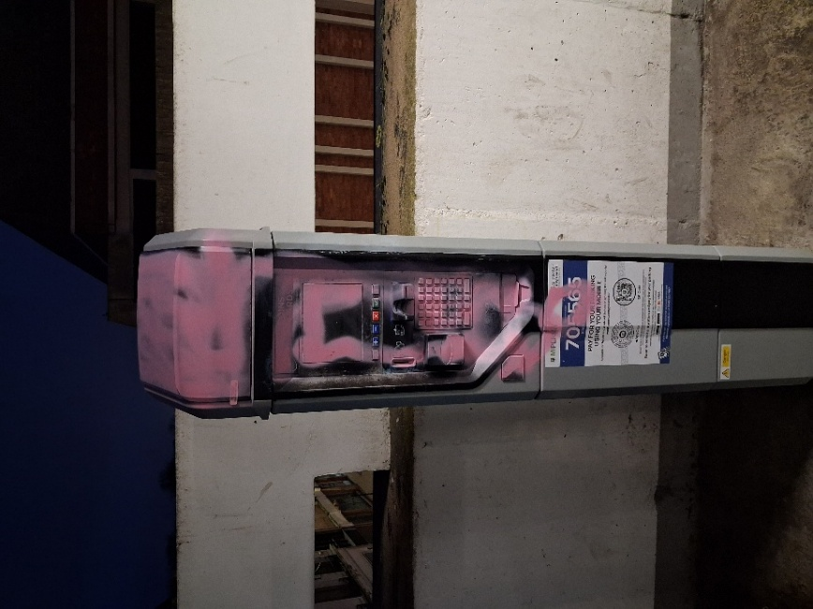

- Graffiti to Light
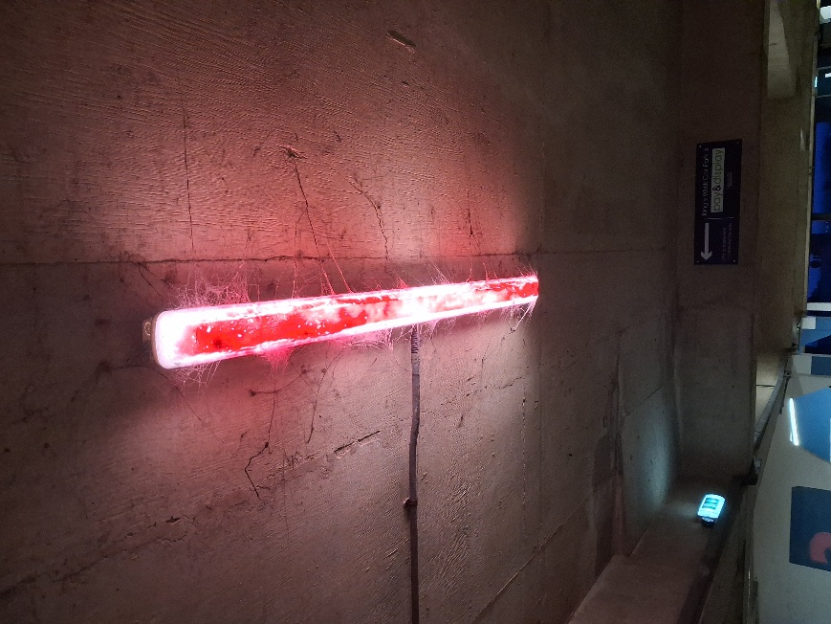

- Inappropriate Artwork (Photo removed)

