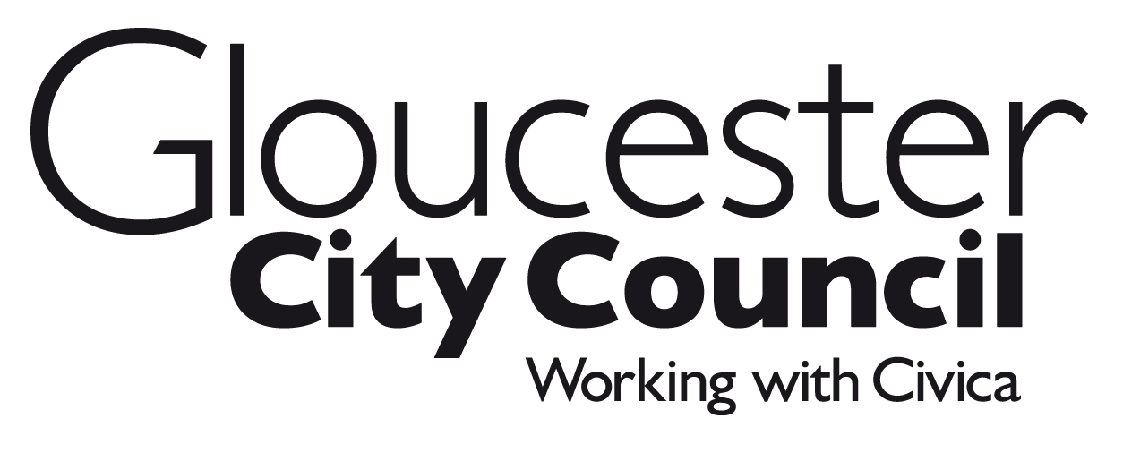
BUSINESS RATES – EXPLANATORY NOTES 2016/17
This document comprises part of your Business Rates Demand Notice.

What are business rates?
Non-domestic rates, or business rates, collected by local authorities are the way that those who occupy non-domestic property contribute towards the cost of local services. Under the business rates retention arrangements introduced from 01 April 2013, authorities keep a proportion of the business rates paid locally. This provides a direct financial incentive for authorities to work with local businesses to create a favourable local environment for growth since authorities will benefit from growth in business rates revenues. The money, together with revenue from council tax payers, revenues support grant provided by the Government and certain other sums, is used to pay for the services provided by local authorities in your area. Further information about the business rates system, including transitional and other reliefs may be obtained at www.gov.uk.

Rateable value
Apart from properties that are exempt from business rates, each non-domestic property has a rateable value which is set by the valuation officers of the Valuation Office Agency (VOA), an agency of Her Majesty’s Revenue and Customs. They draw up and maintain a full list of all rateable values, available at www.voa.gov.uk/government/organisations/valuation-office-agency. The rateable value of your property is shown on the front of your bill. This broadly represents the yearly rent the property could have been let for on the open market on a particular date. For the revaluation that came into effect on 1 April 2010, this date was set as 1 April 2008.

Can I appeal against my property’s rateable value?
The valuation officer may alter the value if circumstances change. The ratepayer (and certain others who have an interest in the property) can appeal against the value shown in the list if they believe it is wrong. Full details on your rights of appeal are available from the Valuation Office Agency. Your billing authority can only backdate any business rates rebate to the date from which any change to the list to have effect.

The VOA will continue to fulfil their legal obligations to alter rating assessments if new information comes to light indicating the valuation is inaccurate. Any alterations they make on or after 1st April 2016 can only be backdated to 1st April 2015.

Further information about the grounds on which appeals may be made and the process for doing so can be found on the www.gov.uk website or obtained from your local valuation office. Legally, rates are payable even if an appeal is underway. Any rates overpaid will be refunded and credited with interest where appropriate.

To make an appeal please contact the VOA on 03000 501 501 or email ratingsouthwest@voa.gsi.gov.uk
How we work out your rates
The local authority works out the business rates bill by multiplying the rateable value of the property by the appropriate multiplier. There are two multipliers: the standard non-domestic rating multiplier and the small business non-domestic rating multiplier. The former is higher to pay for small business rate relief. Except in the City of London where special arrangements apply, the Government sets the multipliers for each financial year for the whole of England according to formulae set by legislation. The current multipliers are shown on the front of your bill.

Business Rates Instalments
Payment of business rate bills is automatically set on a 10-monthly cycle. However, the Government has put in place regulations that allow businesses to require their local authority to enable payments to be made through 12 monthly instalments. If you wish to take up this offer, you should contact your local authority as soon as possible.

Revaluation 2017
All rateable values are reassessed at a general revaluation to ensure bills paid by any one ratepayer reflect changes over time in the value of their property relative to others. This helps maintain fairness in the rating system by updating valuations in line with changes in the market. The current rating list is based on the 2010 revaluation. The Government has confirmed that the next revaluation will take place in 2017 based on rental values at 1st April 2015. More information on revaluation 2017 can be found at: www.gov.uk/government/organisations/valuation-office-agency.

In the year of revaluation the multipliers are rebased to account for overall changes to total rateable value and to ensure that the revaluation does not raise extra money for Government. Similarly, the change in the revaluation date to 2017 has no effect on the total amount of revenue raised from business rates.

Unoccupied property rating
Business rates will not be payable in the first three months that a property is empty. This is extended to six months in the case of certain industrial properties. After this period rates are payable in full unless the unoccupied property rate has been reduced by the Government by order. In most cases the unoccupied property rate is zero for properties owned by charities and community amateur sports clubs. In addition, there are a number of exemptions from the unoccupied property rate. Full details on exemptions can be obtained from your local authority. If the unoccupied property rate for the financial year has been reduced by order, it will be shown on the front of your bill.

The Government has introduced a temporary measure for unoccupied new builds from October 2013. Unoccupied new builds will be exempt from unoccupied property rates for up to 18 months (up to state aid limits) where the property comes on to the list between 1 October 2013 and 30 September 2016. The 18 month period includes the initial 3 or 6 month exemption and so properties may, if unoccupied, be exempt from non-domestic rates for up to an extra 15 or 12 months.

Partly occupied property relief
A ratepayer is liable for the full non-domestic rate whether a property is wholly occupied or only partly occupied. Where a property is partly occupied for a short time, the local authority has discretion in certain cases to award relief in respect of the unoccupied part. Full details can be obtained from the local authority.

Small business rate relief
Ratepayers who are not entitled to another mandatory relief or are liable for unoccupied property rates and occupy a property with a rateable value which does not exceed £17,999 outside London or £25,499 in London will – subject to a small number of exemptions - have their bills calculated using the lower small business non-domestic rating multiplier, rather than the national non-domestic rating multiplier.

In addition, generally, if the sole or main property is shown on the rating list with a rateable value which does not exceed £12,000, the ratepayer will receive a percentage reduction in their rates bill for this property of up to a maximum of 50% for a property with a rateable value of not more than £6,000. The Government has announced, in the Autumn Statement 2015, that the doubling of the usual level of relief – to a maximum of 100% - will continue for a further year, until 31st March 2017.

Generally, this percentage reduction (relief) is only available to ratepayers who occupy either:
- one property, or
- one main property and other additional properties providing those additional properties each have a rateable value which does not exceed £2,599.

The rateable value of the property mentioned in a), or the aggregate rateable value of all the properties mentioned in b), must not exceed £17,999 outside London or £25,499 in London on each day for which relief is being sought. If the rateable value, or aggregate rateable value, increases above those levels, relief will cease from the day of the increase.

The Government has introduced additional support to small businesses. For those businesses that take on an additional property which would normally have meant the loss of small business rate relief, the Government has confirmed that they will be allowed to keep that relief for a period of 12 months.

An application for Small Business Rate Relief is not required. Where a ratepayer meets the eligibility criteria and has not received the relief they should contact their local authority. Provided the ratepayer continues to satisfy the conditions for relief which apply at the relevant time as regards the property and the ratepayer, they will automatically continue to receive relief in each new valuation period.

Certain changes in circumstances will need to be notified to the local authority by a ratepayer who is in receipt of relief (other changes will be picked up by the local authority). The changes which should be notified are:
- the ratepayer taking up occupation of an additional property, and
- an increase in the rateable value of a property occupied by the ratepayer in an area other than the area of the local authority which granted the relief.

Charity and Community Amateur Sports Club Relief
Charities and registered Community Amateur Sports Clubs are entitled to 80% relief where the property is occupied by the charity or the club, and is wholly or mainly used for the charitable purposes of the charity (or of that and other charities), or for the purposes of the club (or of that and other clubs).

The local authority has discretion to give further relief on the remaining bill. Full details can be obtained from the local authority.

Local Discounts
Local authorities have a general power to grant discretionary local discounts. Full details can be obtained from the local authority.

State Aid
The award of such discounts is considered likely to amount to state aid. However it will be state aid compliant where it is provided in accordance with the De Minimis Regulations EC 1407/2013. The De Minimis Regulations allow an undertaking to receive up to €200,000 ‘de minimis’ aid over a rolling three year period. If you are receiving, or have received, any ‘de minimis’ aid granted during the current or two previous financial years (from any source), you should inform the local authority immediately with details of the aid received.
Hardship Relief
The local authority has discretion to give hardship relief in specific circumstances. Full details can be obtained from the local authority.

Rating advisers
Ratepayers do not have to be represented in discussions about their rateable value or their rates bill. Appeals against rateable values can be made free of charge. However, ratepayers who do wish to be represented should be aware that members of the Royal Institution of Chartered Surveyors (RICS - website www.rics.org) and the Institute of Revenues, Rating and Valuation (IRRV - website www.irrv.org.uk) are qualified and are regulated by rules of professional conduct designed to protect the public from misconduct. Before you employ a rating adviser, you should check that they have the necessary knowledge and expertise, as well as appropriate indemnity insurance. Take great care and, if necessary, seek further advice before entering into any contract.

Information Supplied with Demand Notices
Information relating to the relevant and previous financial years in regard to the gross expenditure of the local authority is available at www.gloucester.gov.uk. A hard copy is available on request by writing to the council or by telephoning 01452 396396.

