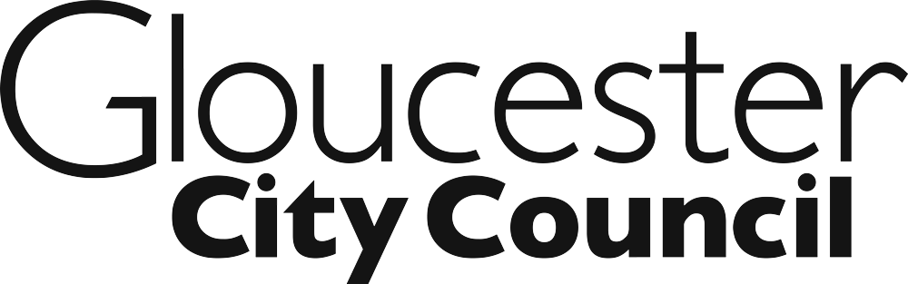

Meeting: | Council |  | Date: | 27th March 2020
Subject: | Pay Policy Statement 2020/21
Report Of: | Cabinet Member for Performance and Resources
Wards Affected: | All
Key Decision: | No | Budget/Policy Framework: |  |  | No
Contact Officer: | Jon Topping, Head of Policy & Resources
 | Email: jon.topping@gloucester.gov.uk |  |  |  | Tel: 396242
Appendices: | - Pay Policy Statement for 2020/21

FOR GENERAL RELEASE

1.0 Purpose of Report

1.1 The purpose of this report is to consider and approve the Council’s Pay Policy Statement for 2020/21.

1.2 Section 38 of the Localism Act 2011 requires local authorities to produce an annual pay policy statement from 2012/13 onwards, which must be agreed annually by full council.

2.0 Recommendations

2.1 Council is asked to RESOLVE that the Pay Policy Statement for 2020/21 attached as Appendix 1 be approved.

3.0 Background and Key Issues

3.1 The Council’s proposed pay policy for 2020/21 is attached to this report. The statement has been developed in response to the requirements of the Localism Act 2011 and follows guidance which accompanied the Act.

4.0 Social Value Considerations

4.1 None

5.0 Environmental Implications

5.1 None

6.0 Alternative Options Considered

6.1 The council is required to produce the statement in accordance with the Localism Act 2011; there is no alternative option on this matter.

7.0 Reasons for Recommendations

7.1 To demonstrate transparency in publication of the Council’s pay policy arrangements in accordance with the principles of the Localism Act.

8.0 Future Work and Conclusions

8.1 None.

9.0 Financial Implications

9.1 None.

(Financial Services have been consulted in the preparation this report.)

10.0 Legal Implications

10.1 Production of an annual pay policy statement is a requirement of the Localism Act 2011.

(One Legal have been consulted in the preparation this report.)

11.0 Risk & Opportunity Management Implications

11.1 The Council must have a current Pay Policy Statement in place in accordance with the legal requirements above.

12.0 People Impact Assessment (PIA) and Safeguarding:

12.1 The PIA Screening Stage was completed and did not identify any potential or actual negative impact, therefore a full PIA was not required.

13.0 Community Safety Implications

13.1 None

14.0 Staffing & Trade Union Implications

14.1 The policy will be shared with the Trade Unions at one of the routine monthly meetings

Background Documents: None

