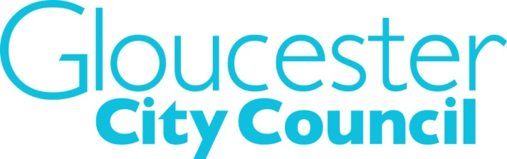

Councillor’s Community Fund Application Form 2022/23
Your Name

Are you applying jointly with
another Councillor (Yes/No)?

Name of other Councillors if a joint bid

Name of group you are funding

Type of organisation e.g. private company, charity, individual etc.
What are you spending your money on?

How much is required from your Community Fund? | £

Declaration of Interest

Do you have a personal interest in this organisation? Yes/No
If yes, please give a brief description of the nature of that interest

By signing this form the Councillor is agreeing that they comply with the terms and conditions within the scheme guidance notes and will not use the funds for any prohibited purpose.

The Councillor will ensure that they and the recipient organisation maintains records on how the grant was spent (i.e. invoices and receipts), and such records will be available to the Council upon request.

Signature: ……………………………………… Date:…………………….

Pre-submission checklist – without these your application cannot be processed

Completed Application

New Supplier form completed

Invoice from beneficiary organisation to Gloucester City Council

Please send completed forms by e-mail only to: grants@gloucester.gov.uk

