Your Green Spaces
We are fortunate in Gloucester to have so many wonderful parks and green spaces giving the City a spacious, open feel.
As well as providing places to walk, play and relax, Gloucester’s green spaces also offer an opportunity to experience daily contact with nature, creating green corridors that bring wildlife right into the heart of the City. Green spaces are also healthy places, restorative and uplifting, providing both physical and mental health benefits. Studies have even shown that living near a green space can increase your life expectancy.
Gloucester’s green spaces come in all shapes and sizes, from Country Parks to sports pitches and formal gardens, and they all require maintenance. In these times of shrinking budgets it is no longer possible for councils to manage public open spaces in the way they did in the past. Most local authorities can now provide only a basic service, with resident and community groups providing additional, complementary, resources where required. These additional resources can take the form of sports clubs marking out and managing their own playing pitches, residents forming friends of groups to help maintain their local parks and gardens or volunteers litter picking their local green spaces.
Hedges and Shrubs - What the Council can do
Hedges and shrubs will be appropriately maintained in order to facilitate safe passage along footpaths and pavements, keep site lines open, ensure road safety, prevent damage to property and encourage wildlife. Brambles and other vegetation will be cut back from paths and walkways if they are restricting access.
What we can’t do
Hedges and shrubs will not be cut back to address shading issues, to facilitate views, to prevent vegetation from encroaching onto private property or to improve television or phone signals to properties. We will not routinely cut back vegetation during the bird nesting season (March to August inclusive)

What you can do
If you are able to do minor works yourself, such as cutting back small branches or brambles overhanging paths, this will enable the Council to direct its resources towards more pressing issues.
Residents can cut back vegetation overhanging their property from council land. Overhanging vegetation can be cut back to the boundary of the property, arising’s must be disposed of responsibly.
If you wish to carry out more major works to Council vegetation you will need to contact the Council to discuss your proposal
What you can’t do
Cut back or reduce hedges or other vegetation on Council land to improve natural light levels, to open up views, to improve television or phone reception or for aesthetic reasons without the prior approval from the city council’s representatives.
If you are aware of an area where there is a problem with vegetation encroaching over a footpath, please fill in the hedge cutting request form or contact the Council on 01452 396396 or email heretohelp@gloucester.gov.uk​​

Hedge and Vegetation Cutting Request Form
Please use this form to report
- vegetation causing access issues along footpaths and cycle ways
- vegetation causing visability problems for motorists and cyclists
- vegetation damaging property
- vegetation that may cause injury to the public
Please note the Council will not normally cut back vegetation to address shading issues, improve television or phone signals, prevent vegetation from encroaching onto private land or to open up views. Non urgent works will be scheduled during the dormant season.
Location of vegetation ……………………………………………………………………………………….
…………………………………………………………………………………………………………………………..
…………………………………………………………………………………………………………………………..
Reason for request .……………………………………………………………………………………………
……………………………..……………………………………………………………………………………………
…………………………………………………………………………………………………………………………
Name ………………………………………………………………………………………………………………..
Address………………………………………………………………………………………………………………
…………………………………………………………………………………………………………………………..
Contact number…………………………………………………………………………………….
Please return completed form to:
heretohelp@gloucester.gov.uk or Neighbourhood Management Services, The Gateway, 92 – 96 Westgate Street, Gloucester, GL1 2EQ

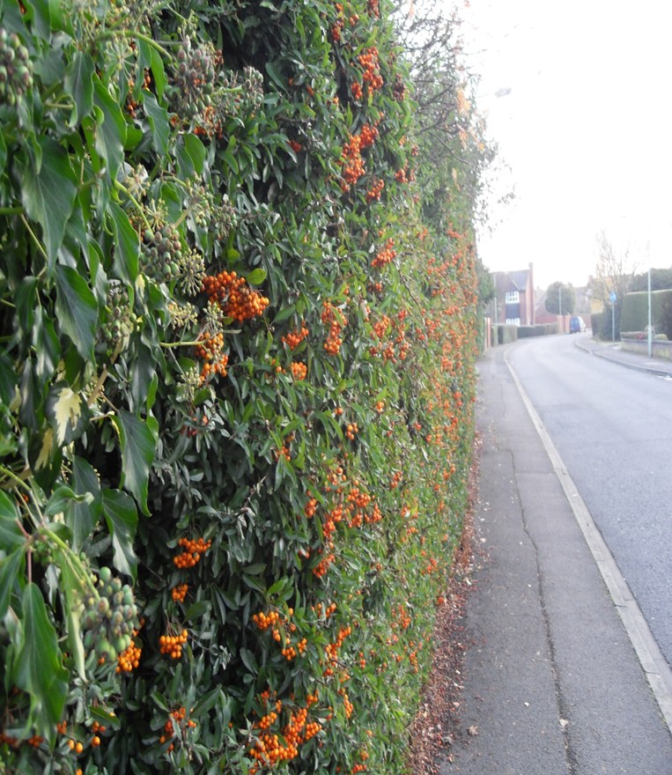
Hedges and Shrubs
Advice and Guidance

