

Consultation for Public Space Protection Order (PSPO)
Longsmith Street Car Park,
Longsmith Street, Gloucester GL1 2HH

Gloucester City Council submits a proposal to apply for a new Public Spaces Protection Order (PSPO) under Section 59 of the Anti-Social Behaviour, Crime and Policing Act 2014. The Council is satisfied on reasonable grounds that –
- activities carried out in the location have had a detrimental effect on the quality of life of those in the locality, or that it is likely that activities will be carried out in the locations will have such an effect and,
- the effect or likely effect of the activities-
- is or is likely to be persistent or continuing in nature
- is or is likely to be unreasonable and justifies the restrictions imposed by the notice.

Background
Gloucester is a vibrant multicultural city that combines historic architecture with a unique blend of visitor attractions. Our city centre boasts a mixture of major stores and independent and regional retailers, many of which are unique to Gloucester and make the city an ideal place to visit. It is important for those living, visiting and working within Gloucester to feel safe, healthy and supported with services we offer as a Council and in collaboration with our key partners.
Longsmith Street Car Park is located in the heart of the City Centre and is used daily by a considerable number of individuals to park their vehicles and use the amenities within the Centre. Gloucester City Council retains ownership of this car park listed within this consultation and is keen to encourage the safe use of these facilities to increase footfall within the city centre.
Over the last 10 years Gloucester City Council has experienced several issues of anti-social behaviour within LONGSMITH STREET CAR PARK located in LONGSMITH STREET, GLOUCESTER GL1 2HH. Activities and behaviours reported to the Council and key partners regarding use of these public spaces include:

  - Individuals taking drugs in full view of customers,
  - Human waste
  - Sleeping in the stairwells
  - Damaging and defacing property including lights in the stairwell
  - Large groups of individuals drinking alcohol around the car park
  - Aggressive behaviour such as fighting and verbal arguments in front of customers.

Reports and observations undertaken by the council have noticeably increased within the last six months, deeming the location as a ‘hotspot’ for criminality and anti-social behaviour.

From evidence gathered, groups of individuals who are behaving anti-socially are not using the car park for its intended purpose. Members of the public who are accessing both car parks for the purpose of parking their vehicles are then often impacted negatively by these behaviours and less likely to return to the location.

The land outlined in red in Schedule 1 are referred to as (“the Designated Area”).

History and Challenges

The Council has no current power to stop persons from socialising or congregating within the Designated Area unless there is evidence that an identified individual(s) has caused alarm, harassment or distress. Identifying and evidencing individuals responsible for anti-social behaviour in an area of high footfall and use can be challenging for varying reasons.
- Between April 25 – January 2026, Gloucester City Council has invested significantly in external security resources to patrol the Designated Area(s) due to the reports of anti-social behaviour. The Council has also undertaken several repairs to damages and invests in a robust cleansing schedule.
- In December 2025, the Council utilised its powers under Section 61 of the Criminal Justice and Public Order Act 1994 which enabled the removal of trespassers on land who are believed to have caused damage, disruption or distress. However no one was found within the Designated Area when Police and Council Officers attended. The Council were forced to close one of the Designated Area(s) for a duration a day due to the extent of damage and cleaning required. Issues of a similar nature returned to the location within a short period of time.
- In February 2026, Gloucester City Council applied to Gloucester County Court for a Civil Injunction on another location due to similar challenges, under the Anti-Social Behaviour, Crime and Policing Act 2014. The application sought an order with a condition to request individuals who were believed to not be using the car park for its intended purpose to leave. Following further legal advice, this was not seen as the most appropriate solution that could be mirrored in other areas.

The Council has received continuous reports of groups or individuals using the Designated Area for the purpose of rough sleeping and the consuming of alcohol and illegal drugs. Gloucester City Council is focused on ending rough sleeping and will engage with and support any individual found within the vicinity of the car parks alongside key partners and agencies. The Council is committed to a graduated ‘Engage, Support, Enforce’ approach where necessary and proportionate when dealing with persons who are believed to be linked to crime or anti-social behaviour within the City.

The Council seeks to make for a Public Space Protection Order (PSPO) to enable authorised persons the power to direct persons from these locations if they have reason to believe that they are not using the Designated Area for its intended purpose and that they are causing, or likely to cause a detrimental effect on the local community.

Data and evidence
Gloucestershire Constabulary Crime Figures from 01/02/2024- 01/02/2026.
Crime Type | Number of Incidents Reported
Theft from Motor Vehicle | 18
Interfere with Motor Vehicle | 4
Criminal Damage to £5000 | 2
Criminal Damage £5000+ | 1
Theft | 1
Assault – Actual Bodily Harm | 1
Common Assault and Battery | 1
Harassment | 1
Possession of Cannabis- Class B | 1
Total | 30
Incidents reported to Gloucestershire Constabulary between May 2025 and October 2025.
  - Incident 329 29/08/25 – 8-9 persons injecting heroin
  - Incident 86 31/08/25 – Person barricading themselves in and sleeping rough
  - Incident 80 13/09/25 – Homeless snorting cocaine and being aggressive
Gloucester City Council Figures 2025-2026 = 36
Annual figures for cleaning and maintenance for Longsmith Street Car Park due to the anti-social Behaviour.
- Since April 2025 – November 2025 £5227.44 has been spend on cleaning and maintenance. The Council have had to call out a specialist cleaning company due to the state which of course costs more money.
- Between April 2024 and March 2025 it cost the council £35,801.25 on cleaning and maintaining the 3 multistorey car parks in Gloucester. The 3 car parks include Kings Walk, Eastgate Street and Longsmith Street.
- Since April 2025 – January 2026 it has cost Gloucester City Council £1,502.26 to hire in security to patrol the multi-storey car parks due to the reports of anti-social behaviour.
- Gloucester City Council has had to request a Contractor to maintain Kings Walk and Eastgate Street Car Park. This table is how many requests over each financial year.

2023-2024 | 25
2024- 2025 | 40
2025 – 2026 (Feb) | 23

Gloucester Neighbourhood Policing Team-

Evidence of this Anti-Social Behaviour in this designated area can be found in Appendix 1
Summary
Gloucester City Council seeks to apply the following conditions for LONGSMITH STREET CAR PARK:
No person shall occupy, loiter in, congregate with other people or use the designated area outlined on the map for any other purpose other than to park a motor vehicle, motorbike or moped.
Where a constable or an authorised person reasonably believes that a person:-
        - is or has been occupying, loitering, congregating with other people or using the Designated Area for any other purpose than parking, or
        - intends to breach the above condition within the order,
the constable or authorised persons may require that person to vacate the Designated Area immediately.
This Order will apply to all land within the Designated Area of Longsmith Street Car Park, Longsmith Street, Gloucester GL1 2HH, including stairwells, lifts and corridors as in Schedule 1.

Consultation
The Council will undertake a consultation from the 07th April 2026 to allow for the opportunity for members of the public and interested parties to submit responses. Submissions for responses will close on 26th May 2026.
If you wish to submit a response to the proposed Public Spaces Protection Order, you can do so via the following methods:
- In writing to ‘PSPO Consultations, Gloucester City Council Gloucester
City Council
Eastgate Management Suite
Eastgate Street
Gloucester
GL1 1PA
- or via email to ASB@Gloucester.gov.uk
- Via our online form here.
More information relating to Public Spaces Protection Orders and live orders across the Gloucester can be found here: Public Spaces Protection Orders | Gloucester City Council

SCHEDULE 1
Longsmith Street Car Park Map
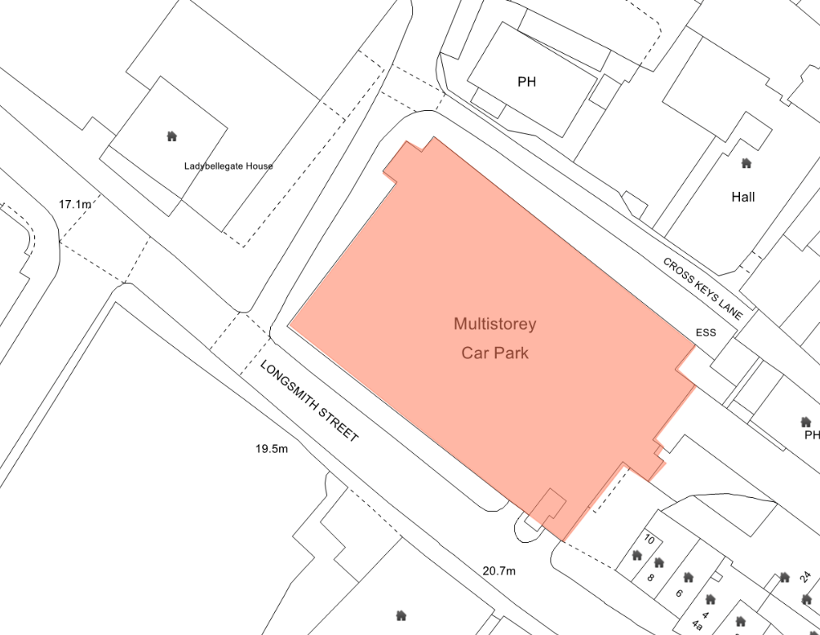

APPENDIX 1
Reports and further information
Member of the public 1 - “To whom this may concern. Today Wednesday the 22nd of October 2025, me and my children used the Longsmith carpark I am writing this as I am very concerned that homeless and drug addicts are using this carpark and its stairway as a public toilet and rubbish bin we parked on the fifth floor and all in the carpark and down the stair way there was rubbish then on the ground floor we was met with a lady who was using a needle in her arm , I think it is absolutely disgusting that this is ran by the local council and you have not done anything about these problems but are still charging members of the public to use it , I myself with not be reusing this carpark and will be making everyone around me aware to avoid too something needs to be done about this absolutely shocking”
Member of the Public 2 - Email from 9th August 2025, “To whomever it may concern. The state of longsmith st car park with regards to street drinking and overnight sleeping has become ridiculous!! This morning (9th August) there were five people in various states of sleep just woken up) one of which was openly injecting some substance into their arms!! The litter are debris around them is also horrendous. I am of the belief that the council own this car park, and a number of cars (assume tourists) saw the state of the car park and simply drove off. Can someone please let me know a contact within the council to contact about this”.
External security - regularly encounter human excrement, individuals sleeping in the stairwells, offensive graffiti and large groups consuming alcohol and illegal drugs.

SABA Supervisor – SABA regularly encounter Human excrement, individuals sleeping in the stairwells and large groups consuming alcohol and illegal drugs. One staff member who cleans the car park is that distressed on what she has to pick up she is considering leaving her job.

21st January 2026 – Photo evidence was provided of the following:
- Blood Stain on the wall

- Blood on Stairwells

- Blood soaked wipes including used needle

15th January 2026- At least 15 used needles collected from the car park. Some of these were found in the Parking Bays.

14th January 2026 - Email stating that he has Witnessed a group of 6-10 individuals consuming alcohol on the bottom floor of LONGSMITH STREET CAR PARK next to the Parent Toddler Bays. 1 member of this group was injecting what he believes is an illegal substance in their thigh.

11th November 2025 – Email stating “due to the continued issues we are facing in Longsmith with homeless people, drug taking, littler, anti social behaviour and the use of the car park as a public toilet, I am going to instruct my teams not to enter the car park until we are able to provide them with a safe working environment.

9th November 2025 – Photo evidence was provided of the following:
- Blood soaked wipes and needle packaging found in the stairwell

- A Mattress left in the stairwell
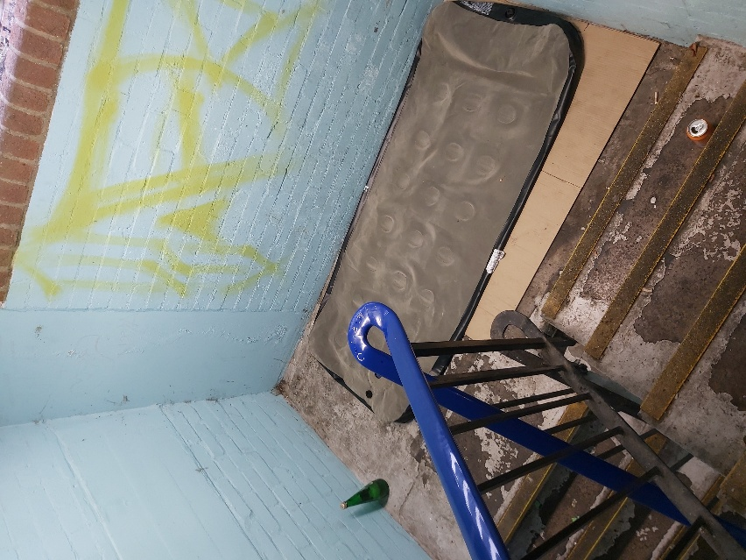

3rd November 2025- Photo evidence was provided of the following:
- Used needle left on the floor of the car park

- Used needle left in an air vent of the car park that faces BULL LANE, GLOUCESTER

14th October 2025 - Photo evidence was provided of the following:
- Uses needle left on top of the gate hook which the team uses to open and close the gates to the car park.

Community Protection Officers (CPOs) - The CPOs have stated that over the last few years this location has become a hotspot for Drug and alcohol consumption and they have seen large groups, sometimes up to 10 people congregate in this area.

20th January 2026 – Photo evidence was provided of the following:

- Used Needles found in Stairwell.
- Used Needles and splattered blood found in Stairwell.

- Used ‘spoon’ issued by VIA and used for heating heroin found in Stairwell.

- Blood soaked wipes found in Stairwell.

15th January 2026 Email from CPOs stating they have witnessed the following at 16:00hrs:
  - 2 known individuals sitting in the stairwell burning a substance which the CPO’s believe was heroin in a ‘Spoon’.
  - 2 unknown individuals sitting at the top of the stairwell intoxicated and drinking alcohol.
  - 2 known and 1 unknown individuals in the other stairwell burning a substance which the CPO’s believe was heroin in a ‘Spoon’.

20th October 2025- Photo evidence was provided from CPOs who attended Longsmith Street Car Park. They also has to dispose of 15 used needles that were left lying around in the car park.
Description of Photos:
- Picture of a number of used needles
- Empty Alcohol Cans behind the wall where this group congregate (CROSS KEYS LANE)
- Empty alcohol Cans and bottles between the Parent and Children Parking (Green parking bay) and the wall used for congregating by CROSS KEYS LANE.

- Used needle and human excrement found in the Stairwell.
- Used needle, Syringe packages and blood soaked wipes.
- Used needle thrown in a locked area of the car park.

Evidence from Gloucester Business Improvement District. – Members of Gloucester Business Improvement have encountered anti-social behaviour at Longsmith Street Car Park for the past last 12 months. They mention about the behaviour of a group of individuals who congregate around the car park daily, individuals sleeping in the stairwell and the general state of the car park. They also receive feedback from concerned businesses with the City Centre as ‘customers’ use this car park.
Photos from 7th October 2025- Photo evidence was provided of the following:
  - Human Faeces in Stairwell / Exit of the Car Park onto BULL LANE, GLOUCESTER

  - Human Faeces in Stairwell of the Car Park Level 5

  - Drug paraphernalia in Stairwell of the Car Park.
  - Burnt mark on a piece of cardboard which I believe is used as drug paraphernalia.

Press Release issued by Gloucester Constabulary 2020 –
Two Women from Gloucester receive civil injunction orders following persistent Drug use”. The two women were found in the stairwell of LONGSMITH STREET CAR PARK, GLOUCESTER injecting themselves. It then states that members of the public were forced to step over their empty alcohol cans and drug injecting paraphernalia to exit the car park.
