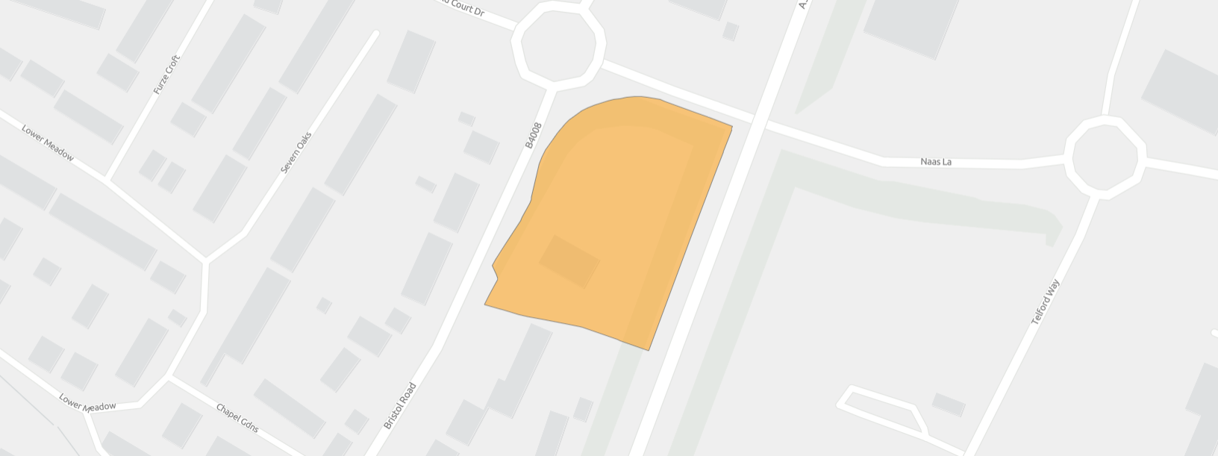
GLOSBR056 Land beside Hardwicke Telephone Exchange, BT Site, Bristol Road
© Crown copyright and database rights 2025 OS AC0000813508

