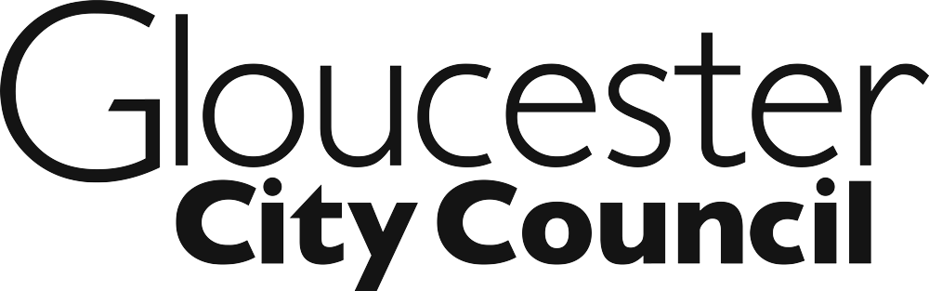

Member Induction 2021

DATE | TIME | SESSION
Tuesday 11 May 2021 | 6.00-8.00pm | INTRODUCTION TO THE COUNCIL  - Welcome to the Council  - Understanding the respective roles of Councillors and Officers  - How the Council works (Executive system, role of districts in two-tier, service areas)  - Council values, behaviours and agile working culture  *compulsory for all newly elected Members*
Wednesday 12 May 2021 | Appointments available between 10.00am and 4.00pm  (alternative arrangements available on request) | ESSENTIAL MEMBER INFORMATION DROP IN SESSION  - Collection of completed forms  - Members’ Allowances  - Member Development  - Modern.gov Committee Management System  *compulsory for all newly elected Members*
Thursday 13 May 2021 | 6.00-8.00pm | STANDARDS AND HANDLING INFORMATION  - Members’ Code of Conduct  - Access to Information  - Freedom of Information and Data Protection  *compulsory for all newly elected and returning Members (separate sessions will be arranged for those returning Members unable to attend this session)*
Monday 17 May 2021 | 6.00-8.00pm | THE COUNCIL’S DEMOCRATIC PROCESS AND MEETING PROCEDURES  - The Council’s Constitution  - Roles of Members and Officers  - Decision-making  - Meeting procedures  *compulsory for all newly elected Members*
Tuesday 18 May 2021 | 6.00-8.00pm | DEALING WITH THE MEDIA AND USING SOCIAL MEDIA  - How to conduct interviews with the press  - How to speak with journalists and answer their questions in succinct, accurate and appropriate ways  - Ways to avoid being misled, misquoted and to always remain on point with the key messages  - Benefits and pitfalls of social media  *compulsory for all newly elected Members*
Thursday 20 May 2021 | 6.00-8.00pm | Members’ Personal Safety  The purpose of the session will be:  - to identify and assess the personal safety risks in the Members work  - to look at some simple to adopt tools to help Members to go about their work safely  - to provide personal safety tips to use and to pass onto others.  *compulsory for all newly elected Members*
Monday 24 May 2021 | 3.00pm | ANNUAL COUNCIL MEETING
Tuesday 25 May 2021 | 6.00-8.00pm | INTRODUCTION TO OVERVIEW AND SCRUTINY  To provide members with a clear understanding of their role in scrutinising the council executive and relevant partner organisations and to develop confidence in developing effective questioning techniques.  • Support members to increase their understanding and experience as effective and confident scrutiny practitioners  • To help improve individual member skills in the basic principles of scrutiny including powers and responsibilities  • To give scrutiny members an increased understanding of the role and potential impact of scrutiny  • To understand how scrutiny can have significant impact in supporting council performance  *compulsory for all new Members of the Committee *
Thursday 27 May 2021 | 6.00-8.00pm | PLANNING AND THE COMMITTEE  An introduction to the planning system and the role of the Planning Committee, to include an assessment of material considerations, planning conditions, legal agreements and reasons for approval and refusal.  *compulsory for all new Members of the Committee and those who have not received refresher training since 2018*
Tuesday 1 June 2021 | 6.30-8.30pm | JOINT SCRUTINY TRAINING  Organised by Gloucestershire County Council.  - Scrutiny review and current structure  - Round table - what does scrutiny look like in your authority?  - Common scrutiny principles  *recommended for all Members of the Overview and Scrutiny and any Members sitting on Joint Scrutiny Committees*
Monday 7 June 2021 | 6.30pm | OVERVIEW AND SCRUTINY COMMITTEE MEETING
Tuesday 8 June 2021 | 6.00pm | PLANNING COMMITTEE MEETING
Thursday 10 June 2021 | 6.00-8.00pm | LICENSING AND THE COMMITTEES  - Alcohol and Entertainment Licensing  - Gambling  - Taxi and Private Hire Licensing  - Other licenses and legislative updates with Probity in Licensing  *compulsory for all new Members of the Committee and those who have not received refresher training since 2018*
Monday 14 June | 6.00-8.00pm | PARTNERSHIP WORKING  - The public agency framework in Gloucestershire/UK, including devolution developments  - Working with communities and voluntary sector, including Asset Based Community Development  - City/County Shared Services Programme  - Question Time Panel with key partners  *recommended for all newly elected Members*
Tuesday 15 June 2021 | 6.30pm | LICENSING AND ENFORCEMENT COMMITTEE MEETING
Wednesday 16 June 2021 | 6.00pm | CABINET MEETING
Thursday 17 June 2021 | 6.00-8.00pm | AUDIT AND GOVERNANCE COMMITTEE  - Role of Internal and External Audit  - Role of the Audit Committee in relation to the annual statement of accounts  - Role of the Audit Committee in relation to governance, risk and control  - The Committee’s standards role  - How breaches of the Code are dealt with  *compulsory for all new Members of the Committee *
Monday 21 June 2021 | 6.00-8.00pm | RISK MANAGEMENT AND COUNTER-FRAUD  Managing risk is an inherent part of delivering organisational success. This session will provide an introduction to the principles of risk management, explain how risk is managed within Gloucester City Council and how risk management can support the delivery of effective public services to the communities within Gloucester City.  *compulsory for all newly elected Members*  *strongly recommended that returning Members attend*2510 J2120
Thursday 24 June 2021 | 6.00-8.00pm | EQUALITIES & DIVERSITY followed by SAFEGUARDING  The session will provide an introduction to Equality & Diversity and Safeguarding in the public sector. It will cover the legislative background, specific duties and requirements for the Council and elected Members and how these are fulfilled by the City Council. The session will be interactive with ample opportunity for discussion and personal reflection on how we embrace diversity and address discrimination at both personal and organisational level.  *compulsory for all newly elected Members*  *strongly recommended that returning Members attend*
Monday 28 June 2021 | 6.00-8.00pm | CUSTOMER ENGAGEMENT  This session will provide an overview of the Council’s customer engagement strategy and how we engage with customers across multiple channels.  We will look at the role customer services have to play in delivering support for our customers and explore how we use reporting, monitoring and customer feedback to improve our services.  The session will be interactive with opportunity for questions, answers and open discussion to help shape a review of our customer engagement strategy.  *recommended for all newly elected Members*
Wednesday 30 June 2021 | 3.00-6.00pm | EFFECTIVE SKILLS FOR COUNCILLORS  Series of workshops:  - An introduction to local government and the wider public sector  - Public speaking and being effective at meetings  - Managing challenging people and difficult situations  *recommended for all newly elected Members*
Monday 5 July 2021 | 6.30pm | OVERVIEW AND SCRUTINY COMMITTEE MEETING
Tuesday 6 July 2021 | 6.00pm | PLANNING COMMITTEE MEETING
Monday 12 July 2021 | 6.00-8.00pm | LOCAL GOVERNMENT FINANCE  The purpose of this session is to provide Members with essential information regarding budgetary matters, understanding statutory accounts and an overview of local government financial matters.  *compulsory for all newly elected Members*
Thursday 8 July 2021 | 6.30pm | COUNCIL MEETING
Wednesday 14 July | 6.30pm | CABINET MEETING
Thursday 15 July | 6.00-7.00pm | CIVICS  - Gloucester’s Civic History, including the role of the Mayor and Sheriff  - Civic events and Members participation  *compulsory for all newly elected Members*
Tuesday 20 July | 6.00-8.00pm | END OF PROGRAMME SESSION – MEET YOUR FELLOW COUNCILLORS AND GLOUCESTER MANAGEMENT TEAM  All Members are invited to attend and get to know their new colleagues and meet the Council’s Senior Managers. Brief welcome from the Managing Director and Leader of the Council. There will also be an opportunity to raise any questions or matters that have not been covered during the Induction Programme and identify any future training requirements.  Newly-elected Members will have the opportunity to meet their allocated Officer Buddy in person.

