
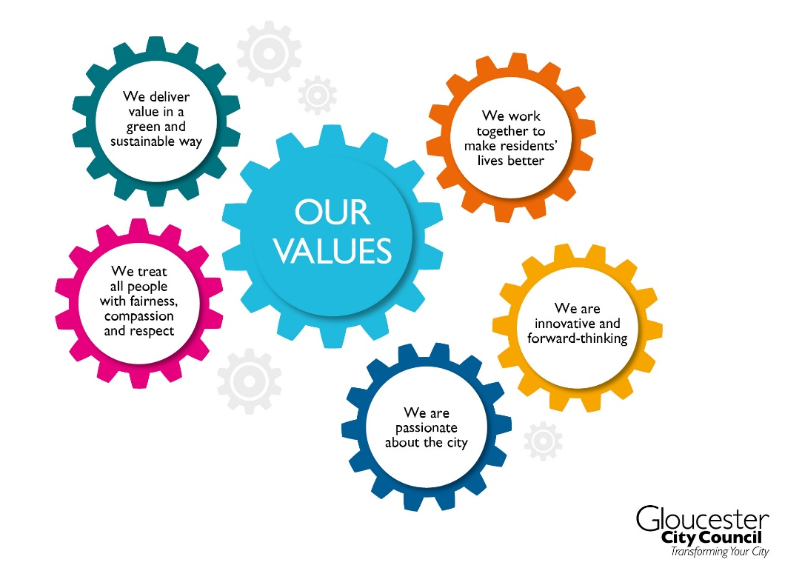
SOCIAL MEDIA ADMINISTRATION POLICY
FEBRUARY 2025

Social Media Administration Policy

1. Introduction
Gloucester City Council is committed to maintaining a safe and respectful environment for all individuals. As part of this commitment, the Council has a statutory duty to protect individuals from harassment, including abuse via digital platforms. This includes alignment with the Worker Protection legislation, which supports proactive measures to prevent harassment.
For the purposes of this policy, individuals refers to employees, volunteers, councillors, agency staff, residents, and members of the public. This policy must also be applied in accordance with wider legislation and statutory guidance, including the Equality Act 2010, safeguarding duties, data protection requirements, the Local Government Transparency Code, and relevant central government and Local Government Association (LGA) guidance on digital engagement and online safety.
Following a rise in abusive, aggressive, and defamatory content posted on social media targeting individuals, this policy has been developed to address these concerns and outlines the standards of behaviour expected from everyone when engaging with the Council’s social media accounts online.
We also recognise that our social media channels are accessed by young people, by vulnerable residents, and by members of all our communities. Maintaining a safe and accessible online space is therefore essential to safeguarding the wellbeing of all users and supporting constructive public engagement.
This policy will be promoted via the Council’s website and social media channels, and sits alongside the Council’s existing Customer Charter and Unacceptable Customer Behaviour Policy, which together provide a broader framework for safeguarding individuals and managing public interactions.

2. Purpose
The purpose of this policy is to provide a clear and practical framework for managing public interactions with Gloucester City Council’s social media accounts.
It is designed to protect individuals from online abuse and harassment, support safe and respectful digital engagement, and guide the Council’s moderation practices.
This policy is operational in nature and focuses on the administration and safeguarding of the Council’s social media presence. y setting clear expectations for behaviour and outlining enforcement mechanisms, this policy contributes to a wider effort to ensure individual safety and uphold respectful public discourse.

3. Scope
This policy applies to all members of the public interacting with Gloucester City Council through its official social media accounts. These currently include, but are not limited to:
Facebook: @GloucesterCityCouncil | Instagram: @BlackfriarsPriory
X (formerly Twitter): @GloucesterCity | X (formerly Twitter): @GlosBlackfriars
Instagram: @GloucesterCityCouncil | Facebook : @GlosGuildhall
LinkedIn: @Gloucester City Council | Instagram: @GlosGuildhall
X (formerly Twitter): @VisitGloucester | X (formerly Twitter): @GlosGuildhall
Instagram: @visitgloucester | LinkedIn: @Gloucester-Guildhall
Facebook: @Gloucester | X (formerly Twitter): @MuseumOfGlos
TikTok: @visit_gloucester | Facebook: @MuseumofGloucester
Threads: @visitgloucester | Threads: @museumofgloucester
LinkedIn: @Visit Gloucester | Bluesky: @museumofgloucester.bsky.social‬‬
Facebook: @GloucesterBlackfriars

It covers all forms of engagement with these platforms, whether through comments, messages, tagging, or sharing Council content.

4. Standards of Behaviour
Gloucester City Council welcomes feedback and discussion across its social media platforms. To help maintain a safe and respectful environment, the Council reserves the right to take action on unacceptable, abusive or harmful content directed at any individual, including but not limited to the following categories:

4.1 Abusive or Offensive Behaviour
- Abusive, obscene, threatening, or harassing language or imagery
- False accusations against individuals
- Defamatory or malicious statements
- Disinformation or conspiracy theories
- Content that violates laws or regulations
- Intellectual property infringement
- Provocative or hostile tagging or mentions
- Inappropriate or suggestive remarks about individuals

4.2 Invasion of Individual Privacy
- Naming individuals
- Sharing personal information, images, or recordings of individuals without explicit permission

4.3 Discriminatory Content
- Language or imagery that discriminates based on age, disability, gender or gender reassignment, marriage and civil partnership, pregnancy or maternity, race, religion or belief, sex, or sexual orientation

4.4 Excessive or Repetitive Contact
- Posting the same or similar message multiple times or across threads
- Persistently contacting the Council or individuals without presenting new information
- Repeated tagging, messaging, or commenting that continues after being asked to stop

4.5 Unsafe Sharing of Personal Information
- Publicly posting sensitive personal details
- Using comment threads for private matters instead of secure channels

4.6 Misuse of Council Branding
- Using Council logos, photos, or branding without prior written permission

5. Reporting Concerns and Allegations
Making allegations against individuals on social media or any other platform can constitute criminal and civil wrongs and will be removed. Legal action may follow where appropriate.
Gloucester City Council takes all concerns about the conduct of anyone connected to the organisation very seriously. We have established procedures for reporting and investigating such matters. If you need to report wrongdoing, please use one of the following channels:
https://www.gloucester.gov.uk/about-the-council/fraud-and-whistleblowing/whistle-blowing/
Write to: The Monitoring Officer, Gloucester City Council, Eastgate Management Suite Eastgate Street Gloucester GL1 1PA
These routes ensure that concerns are handled appropriately and in line with the Council’s legal and ethical obligations.

6. Moderation and Enforcement

Moderation Approach
Gloucester City Council has a responsibility to maintain a safe, respectful and accessible online environment for all users, including young people, vulnerable people, and members of all our communities. We will therefore moderate content that poses a risk to the safety, dignity or wellbeing of others, or which falls within the unacceptable behaviours set out in this policy.
The Council has well-established and formal processes for raising concerns about the conduct of councillors or officers. Social media is not an appropriate channel for making such allegations, and posts that make baseless, unsubstantiated or harmful claims will be removed in accordance with Section 5 of this policy, which directs individuals to the proper complaints and whistleblowing routes.
The Council also has a responsibility to challenge misinformation and disinformation where it risks misleading residents, undermining trust in services, or causing public harm. Content that spreads false or misleading information may therefore be removed or corrected to protect the public and ensure accurate understanding.
Our moderation decisions will focus on behaviour that creates risk, harm or disruption, rather than on differences of opinion. The Council welcomes constructive challenge, feedback and scrutiny made through appropriate channels, but we will take action where online behaviour becomes abusive, harmful, intimidating, discriminatory or misleading.

Enforcement Actions
Gloucester City Council actively monitors its social media accounts to ensure a safe and respectful environment for all users and staff. Where content breaches this policy, the Council reserves the right to take appropriate action without prior warning. This may include:
- Hiding or deleting comments that breach this policy
- Blocking users who repeatedly or seriously violate these standards
- Reporting serious breaches to the relevant social media platform and/or law enforcement
- Limiting or disabling public replies on specific posts where necessary
These actions are taken to uphold the standards outlined in this policy and to protect individuals from online abuse, harassment, and other forms of unacceptable behaviour.

7. Appealing a Moderation Decision
Anyone who feel that this policy has been unreasonably or incorrectly applied to their posts can raise the matter through Gloucester City Council’s formal complaints process. All complaints received will be investigated in line with the Council’s complaints procedures, and a response will be provided to the complainant.
This ensures transparency, accountability, and an opportunity for individuals to have moderation decisions reviewed.

8. Policy Approval and Review
This operational policy is approved by the Head of Paid Service and forms part of Gloucester City Council’s wider commitment to maintaining a safe and respectful environment for all individuals.
It will be reviewed annually to ensure it remains proportionate, effective, and aligned with relevant legislation, platform terms of use, and patterns of public engagement. Updates may be made in response to emerging risks, feedback, or changes in Council operations.

Policy History
Author: Head of Transformation and Commissioning
Adopted date: October 2025
Next review date: October 2026
History of most recent policy changes – Amended with complaints procedure and clarity on moderation.
Date: October 2025 – Policy first adopted.
February 2026 – Updated based on feedback.

