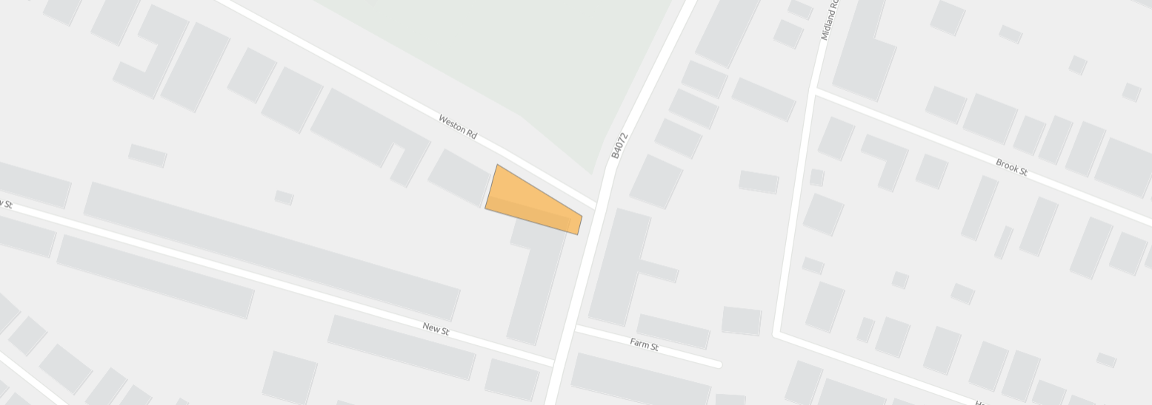
GLOSBR057 108 Weston Road
© Crown copyright and database rights 2025 OS AC0000813508

